**Requirement Gathering and Analysis Phase**

**Data Flow Diagram & User Stories**

|  |  |
| --- | --- |
| Date | 06 July 2024 |
| Team ID | SWTID1720010842 |
| Project Name | Book a Doctor |
| Maximum Marks | 3 Marks |

**Data Flow Diagram:**

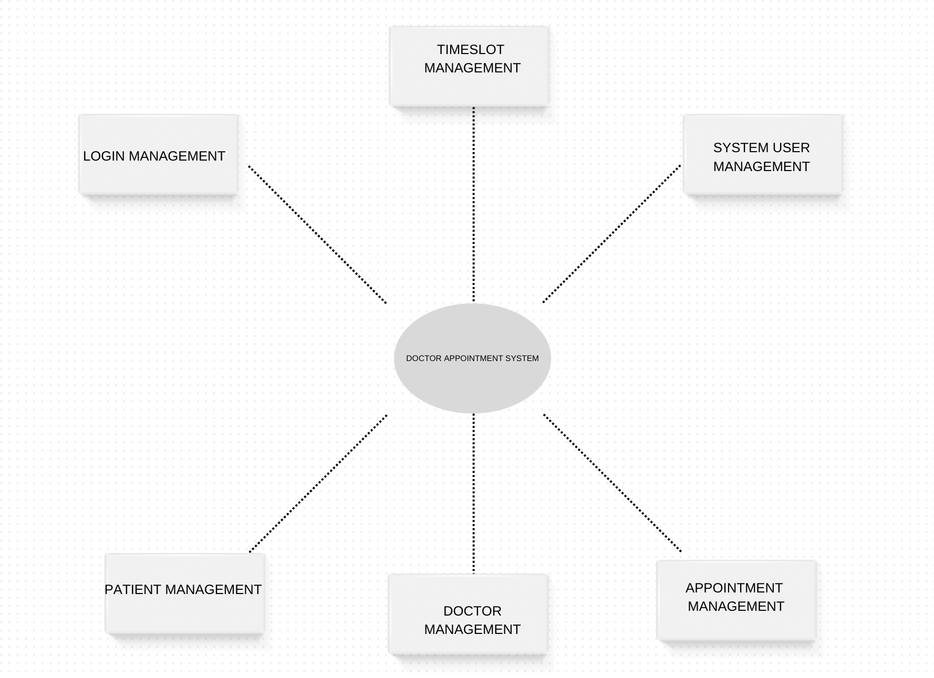

**User Stories**

| **User Type** | **Functional Requirement (Epic)** | **User Story Number** | **User Story / Task** | **Acceptance criteria** | **Priority** | **Release** |
| --- | --- | --- | --- | --- | --- | --- |
| Patient | Registration | USN-1 | As a patient, I can register for the application by entering my email, password, and confirming my password. | I can access my account / dashboard | High | Sprint-1 |
|  |  | USN-2 | As a patient, I will receive confirmation email once I have registered for the application | I can receive confirmation email & click confirm | High | Sprint-1 |
|  |  | USN-3 | As a patient, I can register for the application through Gmail |  | Medium | Sprint-1 |
|  | Login | USN-4 | As a patient, I can log into the application by entering email & password |  | High | Sprint-1 |
|  | Appointment | USN-5 | As a patient, I want to book an appointment with a doctor online so that I can see a doctor without visiting the clinic in person. |  | High | Sprint-1 |
|  |  | -USN 6 | As a patient, I want to view my upcoming appointments so that I can keep track of my visits. | I can receive notifications regarding appointments | Medium | Sprint-1 |
|  |  | -USN 7 | As a patient, I want to reschedule an appointment online so that I can change my appointment time to a more convenient slot. | I can receive confirmation email & click confirm | High | Sprint-1 |
|  |  | -USN 8 | As a patient, I want to view my medical history and past appointments so that I can keep track of my health records. | I can access my account / dashboard | High | Sprint-1 |
| Doctor | Appointment | -USN 1 | As a doctor, I want to view, accept, or reject appointment requests so that I can manage my schedule efficiently. | Doctor can see all appointment requests. | High | Sprint-2 |
|  | Information | -USN 2 | As a doctor, I want to access patient medical history and past visits so that I can provide better care. | Doctor can view detailed patient medical history. | High | Sprint-2 |
|  | Availability | -USN 3 | As a doctor, I want to update my availability so that patients can book appointments only during my working hours. | Doctor can update available time slots. | High | Sprint-2 |
|  | Notifications | -USN 4 | As a doctor, I want to receive notifications for new appointments, cancellations, or changes so that I am always informed. | Doctor receives notifications for new, cancelled, or rescheduled appointments | Medium | Sprint-2 |
| Administrative Staff | Approval | -USN 1 | As an admin, I want to approve or reject doctor profiles so that only verified doctors can use the system. | Admin can activate/deactivate patient accounts. | Medium | Sprint-3 |
|  | Manage | -USN 2 | As an admin, I want to manage patient accounts, including activation and deactivation, so that the system is secure. | Admin can activate/deactivate patient accounts | High | Sprint-3 |
|  | Reports | -USN 3 | As an admin, I want to generate reports on appointments, doctor performance, and patient feedback so that I can monitor the system's effectiveness. | Admin can generate detailed reports. | Medium | Sprint-3 |
|  | Notifications | -USN 4 | As an admin, I want to send system-wide notifications to doctors and patients so that everyone is informed about important updates. | Admin can send notifications to all users.. | Low | Sprint-3 |
| Technical Support | Resolve Technical Issues | -USN 1 | As a technical support agent, I want to view and resolve technical issues reported by users so that the system remains functional. | Technical issues can be logged and tracked | High | Sprint-4 |
|  | Monitor System Performance | -USN 2 | As a technical support agent, I want to monitor the system's performance and uptime so that any issues can be addressed promptly. | System performance metrics are monitored in real-time. | Medium | Sprint-4 |
|  | Provide User Assistance | -USN 3 | As a technical support agent, I want to assist users with their queries and issues so that they have a smooth experience using the system. | Users can contact support via multiple channels (chat, email, phone) | Medium | Sprint-4 |